


AWS Solution Architect Training with AWS Cloud Practitioner Global Certification
Capstone Projects

Trainer: Aravindraj.G- Nminds Academy
AWS Academy Certified Educator

Create an EC2 Windows Instance in AWS



Gokul.S

Objective
EC2 (Elastic Compute Cloud) is a core service provided by Amazon Web Services (AWS) that enables users to rent virtual servers in the cloud to run applications, store data, or handle computational workloads.

An EC2 Windows instance is a virtual machine running the Microsoft Windows operating system on Amazon Web Services (AWS) EC2 (Elastic Compute Cloud). This allows you to run Windows-based applications, manage Windows Server configurations, and use various Microsoft software (like SQL Server, IIS, etc.) in the cloud without having to manage physical hardware.

Use Cases for EC2 Windows Instances:
- Web and Application Hosting: Run IIS web servers or other Windows-based web applications in the cloud.
- Database Servers: Host SQL Server databases with EC2 Windows instances, using RDS or EC2 for more control.
- Remote Desktop Applications: Set up RDS (Remote Desktop Services) for remote access to Windows desktops in the cloud.
- Development and Testing: Create development environments with Windows OS to test .NET or other Windows-based applications.

Used Services in AWS:
Amazon EC2

Topology

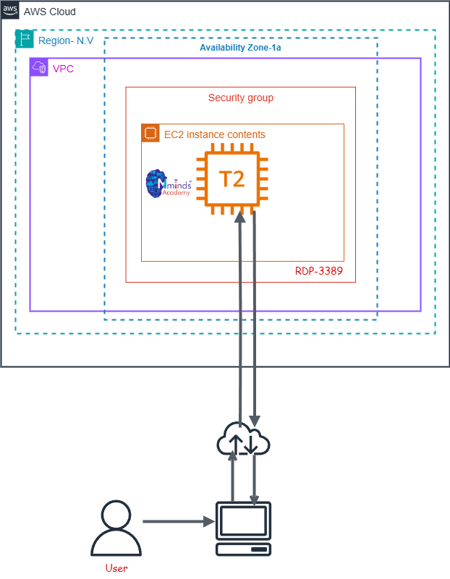

Execution Tasks:

